MANUAL 1.0

MOTILITY MAP 3.0

April 2010

Wim Lammers
Department of Physiology
Faculty of Medicine & Health Sciences
P.O. Box 17666, Al Ain
United Arab Emirates

fax: 971-3-7671966
e-mail: wlammers@smoothmap.org
www.smoothmap.org

CONTENT:

- Introduction 3

- What is new? 4

- Window #0: File import and calibration 5

- Window #1: Tracking Window 9

- Window #2: Dot Tracings 24

- Window #3: Border Tracings 31

- Window #4: Play Back (and making movies) 35

- Technical details and Tips 36

- Supporting files 37

- References 37

WARNING:
You are running this software at your own risk. Although I have tried to develop this software as best as I can, there are certainly bugs and mistakes in the subroutines. I have discovered many of those but there are undoubtedly several left. If you discover a problem, an inconsistency, plain errors or malfunctions, let me know and I will do my best to resolve these. Nevertheless, it must be clear that the use of this software, the data derived from it, the ensuing analysis and the potential conclusions are not my responsibility but reside fully and unequivocally with the user.

Wim Lammers, April 11, 2010
INTRODUCTION:

Motility Map is a program that has been designed to track the movements of (smooth) muscles. It started by tracking the displacements of markers (dots) that had been applied on the surface of isolated tissues (1, 2). Later, it was extended to track the border of tubular segments and to tracking particular areas (3).

Motility Map analyzes displacements that have been recorded with a digital camera and stored in QuickTime format. The program is written in REALbasic and runs on a Macintosh; a Window version is no longer available (just too complicated and it made the whole program very unstable!).

Motility Map has been developed and used in my lab for several years now but also by others. Depending on developments in my own lab or in that in others, bit and pieces were added without too much time for debugging or proper writing and testing. Bugs were often found with little time for these to be resolved. Finally, the lack of a manual started to impede its use.

All this has lead me to undertake a massive re-think and re-write of the program and the development of a manual to explain its major facilities. This work started in the summer of 2009 and took too long before it finally reached a conclusion.

In this manual, I will try to be as brief as possible. In the accompanying website (www.smoothmap.org), there are several supporting files to test and illustrate some of the facilities of this program.

The current version has been tested in many ways. However, there are so many options, possibilities and combinations that not everything could be tested. As usual, if you find a problem, a bug, an unexpected outcome, or even a crash, please let me know as soon as possible so that I can fix these issues in a next version of Motility Map.

Wim Lammers
Al Ain, UAE, April 2010

What is new?

For those who have used previous versions, you will see that there has generally been a massive clean up. Many options, labels and even windows with several experimental or half-heartened trials have been abolished and removed.

A new addition is the development of border tracking along a curved segment. For this I used a Bezier curve with handles perpendicular to the axial curve.

The most important change in MotilityMap is the fact that the results of the tracking and of the analyses of the traces are saved in a text file. This makes it possible to import all data in other applications such as Excel, Matlab etc. The stored data are the raw data, that is to say they indicate the position of the tracked dot or border in pixels, according to the coordinates in the original window. This will give users maximal flexibility as to how they want to work with their data. A more extensive discussion of the saved text format is given at pages 21-23.

Window #0: FILE IMPORT AND CALIBRATION.

In this first and main window, the user can import and calibrate a digital video file.

- Video format.
The program has been extensively used and tested with QuickTime format. In principle, it should also be possible to import other formats (.avi, , .dv, .mpeg, .mp4) but unfortunately, because of the lack of a standard in digital video formats, there is no guarantee whether a file with a different format will work (such as .wmv). However, there are numerous (free) converting websites that will easily convert other formats to QuickTime if necessary (just google “how to convert video files?” to get the latest).
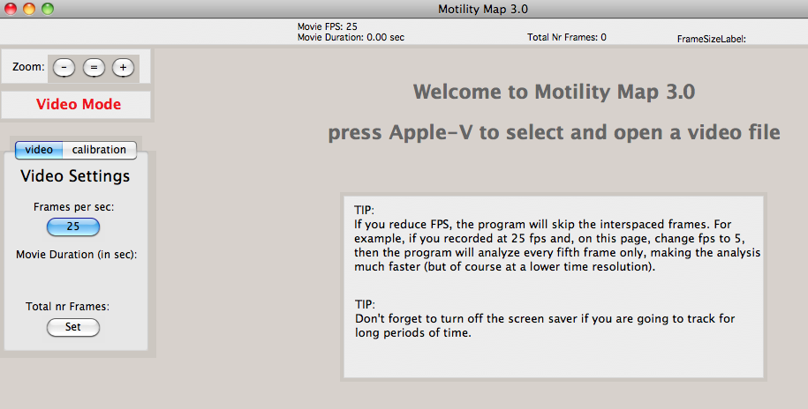

- FPS (frames per second).
Frames per second is one of the most important determinants of the video files. Most commercial video recorders will have a FPS of typically 25 FPS, which is more than enough for recording smooth muscles displacements. The maximum capacity of Motility Map is currently 9000 frames, which at 25 fps, translates to 360 seconds (6 minutes), which should be enough for most practical purposes. If you have longer files or the movements are really very slow (as with uterine contractions) you could lower FPS to 10 or even 5. The program will then skip intermediate frames and you can analyze longer segments.
When a video file is imported, an attempt is made to obtain file information from its header. Because of the lack of a standard, sometimes the FPS is wrong. You can correct this manually by pressing the “FPS” button and inserting the right value.
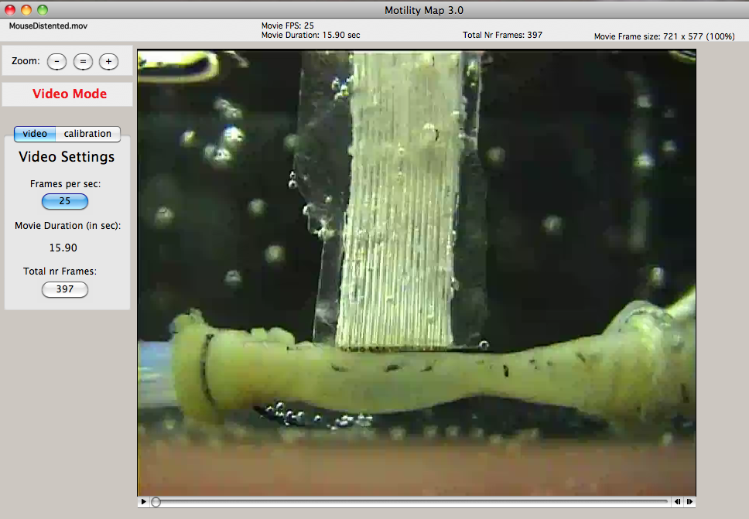

CHECK: the (calculated) movie duration should correspond with your orginal video file. If not, something is wrong with the FPS or the video header.

- Zoom:
In the upper left of the screen, there are three buttons to increase, decrease or return to the original size of the video. In QuickTime format, you can also play the movie (to make sure you have selected the right file?) by clicking on the arrow below the movie.

- Calibration.
This window offers the possibility of calibrating your video. Pressing on the Calibration tab will take you to the Calibration window. For this I often use a piece of recording in which a ruler or a piece of graph paper (I have plastinated a small piece of graph paper for this purpose) is visible on the screen. With the mouse, I click on the beginning of a mark and drag along the required distance, in this case 16 mm (the width of the electrodes was 16 mm). In the left panels, the amount of pixels and mm are indicated. Pressing the “mm” button, allows me to insert the correct distance. The other buttons makes it possible to select the location (X and Y) and orientation (vertical or horizontal) of the calibration scale in the next window.
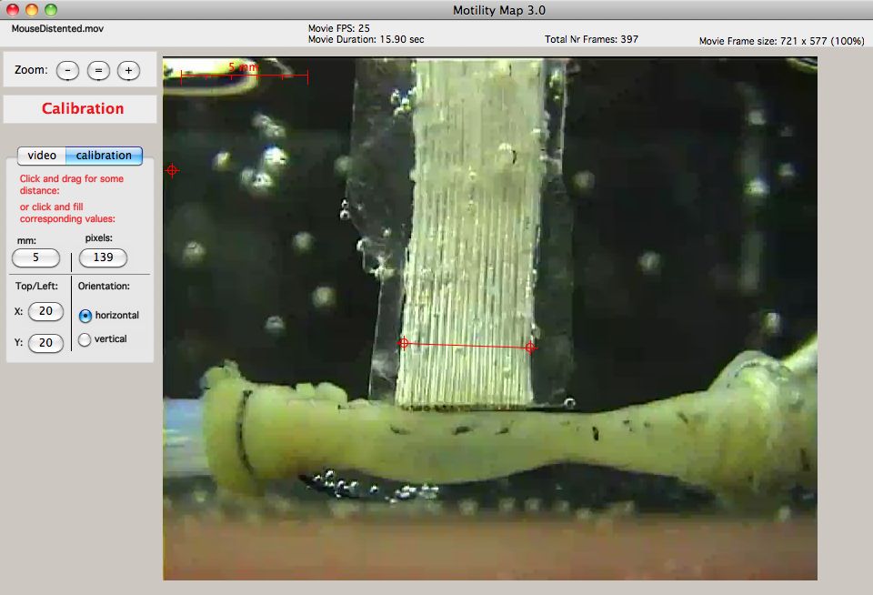
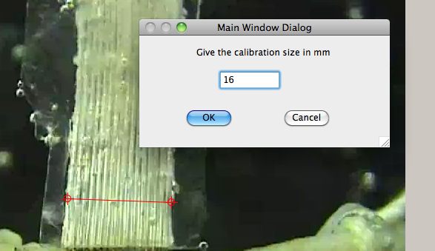

If you already know the calibration of your video (because you have already analyzed previous segments), then you don’t have to measure anything on the screen and just fill in the appropriate values for “mm:” and “pixels:”.

Menu Bar: File:
There are several options (and keyboard shortcuts) available in this menu:
- Open Video (apple-V): opens a video file
- Open Calibration (apple-C): opens a calibration image, usually a jpeg.
- Open Dot file (apple-D): opens a previously saved text file that contains the results of a dot tracking/analysis.
- Open Border file (apple-B): open the same following a border tracking/analysis.
- Open Area file (apple-A): same for an area tracking/analysis.
- Read Dot List (apple-L): opens a text file containing the dot numbers to be analyzed.
- Read Chain List: opens a text file containing the data required for a chain analysis.
- Save Tracked data (apple-S): this will save the tracking (and analysis) that you have performed.
- Save as Jpeg (apple-J): save the current picture or graph in an image file.
- SaveToMacPict: a routine for my own lab to save graphics data in a format to be used in other applications.
- Page SetUp (shift-P): shows/modifies the current print settings
- Print … (apple-P): prints the current graph.

Menu Bar: General:
- Zoom step (apple-Z): give new value for the zoom step (default 25%).
- Inc Zoom: increase the size of the image according to the current zoom step
- Dec Zoom: decrease the size of the image according to the current zoom step
- Org Zoom (apple-=): go back to the original size
- Show selected area: show additional (video) areas for debugging purposes.

CAUTION: Although it is possible to insert an image and used that to calibrate the video, in my experience, the image (jpeg or whatever) has often a different size than the video (which makes calibrating the video more difficult). You can check this by comparing the two sizes as displayed on the top panel. This is why I always try to calibrate from the video itself if possible.

PRINT: It is possible to print the windows and the graphs in several Windows. The size and orientation can be modified in the shift-P option. I usually choose landscape orientation and reduce the size to 80% but this will depend on your own printer and its configuration.

Window #1: TRACKING WINDOW.

This is the heart of the program. This is where you decide what part of the screen you want to track the recorded movements or displacement in time. The screen is filled with several panels to provide you with information and choices that have to be made before starting the tracking.
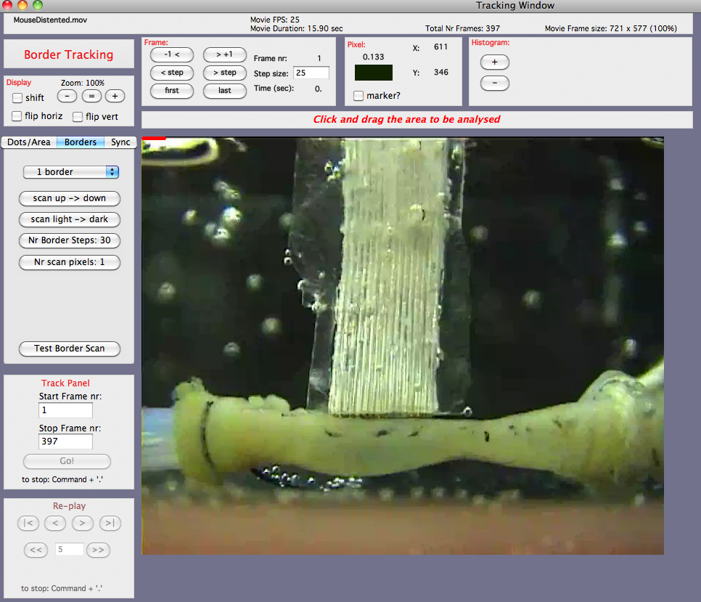

The Display Panel:
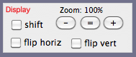 | Part of this panel was already visible in the Import window (#0); the zoom buttons and their functions are the same as in that first window.

New buttons are the check buttons “flip horiz” and the flip vert” buttons that, when checked, will flip the whole picture in the horizontal and/or the vertical direction.
The “shift” check is a bit more complicated but works to help the zoom button. Sometimes, if the area of interest is located in the lower right corner, this may shift out of the screen when the zoom factor is too high. The user can then click the “shift” check and a hand cursor will appear on the screen. With this “hand”, one can shift the whole screen in any direction to shift the area of interest, usually back to center stage. WARNING: don’t forget, after the shifting, to uncheck the “shift” check as many functions are disabled in this “shift” mode.

The Frame Panel:
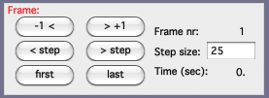 | The Frame panel provides for a crude way to navigate through your movie. The “-1 <” and “> +1” will move the movies one frame forward or backward.
The “first” and “last” button will move the movie to the first or last frame while the “”< step” and “> step” buttons will move the movie one step size forward or backward. The size of the step can be modified in the Step Size field, which is set at 25 frames (default 1 second). Above and below the Step Size edit field, the current frame number and time are displayed.

The Pixel Panel:
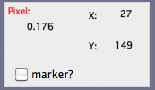 | The pixel panel provides some information on the pixel values at the tip of the cursor, such as its location (x and y with the 0,0 coordinates in the upper left corner), the color of the pixel and its B/W value.
This panel also provides the opportunity of measuring distances on the screen. When the “marker” check is pressed, then the cursor displays a “bull’s eye”. A first click will position the beginning of a line, move (not drag!) the cursor to another location and a second click will update the distances displayed on the panel while a third click will start the process all over again.
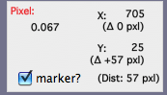 | 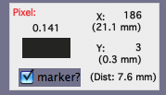
The distances plotted are shown in pixels if there is no calibration (left figure), or in the correct unit if calibrated (right figure).

The Histogram Panel:
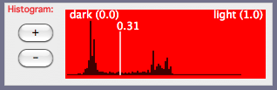
This panel displays the population of pixels (in black and white) of a selected area on the screen (see later), similar to that in other graphic programs such as in Photoshop. Left in the panel is black (value 0.0) and right is white (value 1.0; these are the same units as shown in the Pixel panel). The “+” and “-“ button increase and decrease the histogram magnification respectively. This histogram is used to determine a threshold for the tracking. Clicking, in this panel, in the red window, can set this threshold and the vertical white line indicates the chosen value with the value plotted on top (in this case 0.31).

NOTE: Detecting a threshold in MotilityMap is performed by using the black/white property of the pixels; not the colors! Theoretically, this could have been done but I did not see a real need for this. However, since the detection of a threshold is determined in B/W, the contrast of a border or a dot is important. The higher the contrast, the better the detection performs.

The Message Panel:
The message panel is used to convey additional information to the user. During tracking, it changes into a progress bar.

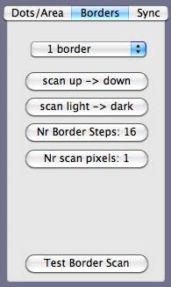 | All panels are important but this is certainly a crucial panel. With this, several type or mode of tracking can be chosen. At the moment, there are three tracking modes:  a) Dots/Area  b) Borders  c) Sync  The “Borders” mode is the default because most people use it.

In the “Border” mode, there are several buttons available to tailor this tracking.
The first button is a pull-down menu with the following alternatives:
- 1 border
- 2 borders
- curved borders.

Border Mode. 1 Border:
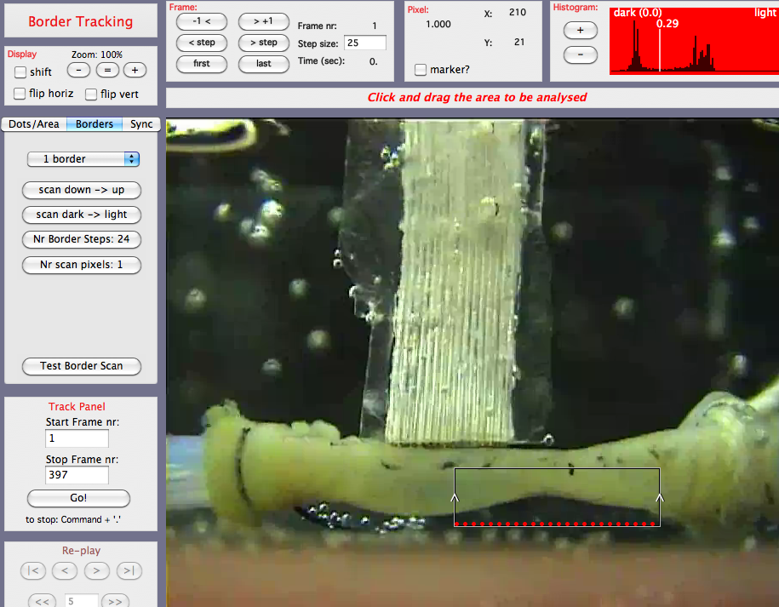
As shown in this figure, the first step, after having chose one mode (“1 border”), is to click and drag the area of interest, in this case, encompassing the lower right border of the intestine. Automatically red dots will appear along one horizontal edge of the selected area. The number of dots is calculated automatically but can be changed by pressing the “Nr Border Steps:” button, which now shows 24. At the two vertical sides of the selected area, two (primitive) arrows point upwards. This indicates the future direction of scanning (from ‘down’ to ‘up’). If necessary, this can be changed by pressing the “scan down -> up” button.
At the same time, the histogram panel shows the distribution of pixels in this area which generally falls into a lighter group and a darker group. The threshold was set somewhere in the middle of the two groups, in this case, at 0.29.
Another important scan parameter is whether one scans from light to dark or from dark to light. The corresponding button in the border panel sets this direction.

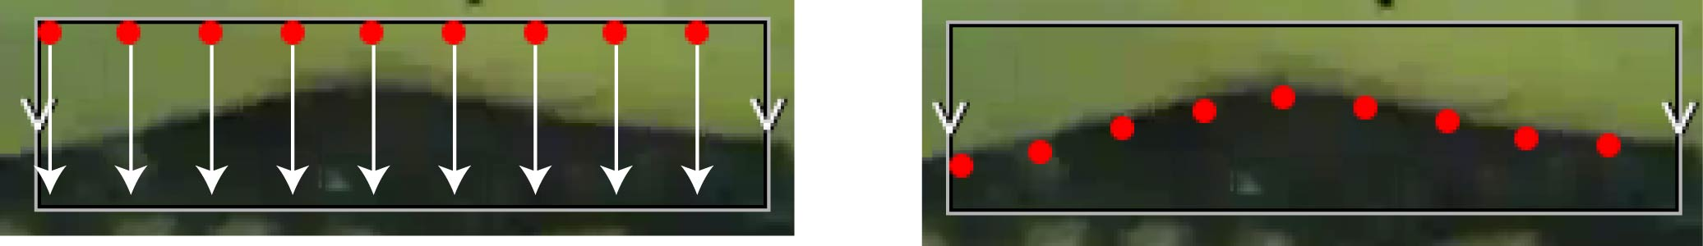
Left figure: detail of the border tracking just before the test. Direction is up>down and light to dark. Each vertical white arrow indicates the path of tracking for that particular red dot. As the threshold is reached (from light to dark), the border is detected and the position of the red dot is shifted to the detected threshold (i.e. the border; right figure)

Scanning the border consists of the program searching along a vertical line, in the selected area, the location of the pixel that reaches and exceeds the threshold value. If, as in this case, one wants to scan from the dark background to the lighter tissue, then the scan direction is down -> up and from “dark to light”. It could also have been set in the other direction, from up to down and from light to dark. If the background had been white, and lighter than the tissue, then the scan direction could have stayed the same but one would have scanned from “light to dark”.
Fortunately, before committing to a time-consuming tracking, one can test the settings of all these buttons by pressing “Test Border Scan”. If something is not set properly, this can now be corrected and tested again.
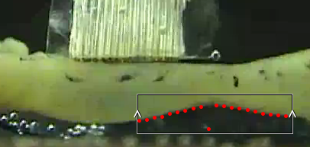 | This figure shows a relatively successfully test (settings “down->up” and “from dark to light”). Notice that one dot did not reach the border as it found a lighter impurity first in the fluid.

Note that the default scanning occurs along a single vertical line which has a width of 1 pixel. If for some reason, as occurred once in this case, the value of a pixel exceeds the set threshold, then the scanning of that dot stops. In this version of Motility Map (3.0), I have implemented the possibility of scanning across more than one pixel. In this example, the “Nr scan pixels” has been increased from 1 (default) to 10. I have also decreased the nr of border steps to 10. Testing this setting (figure below) shows that this solved the problem of the impurity in the fluid. Alternatively, one could also have scanned from up-> down and from light -> dark of course!
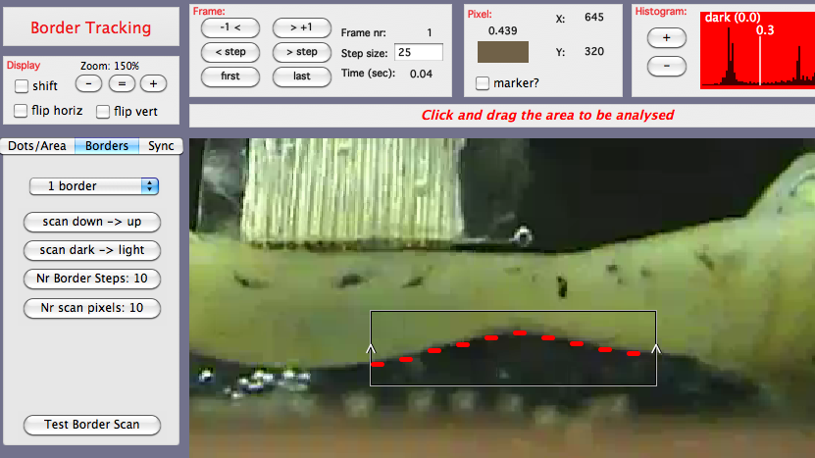
Note by the way that I have, in this figure, also magnified the display to 150% and shifted (with the shift hand) the area of interest closer to the panels.

Border Mode. 2 Borders:
2-Borders tracking is very similar to 1-border tracking. As shown in the figure, if this option is chosen, the selected area is split horizontally. The idea is that one border falls in the upper area and the opposite border in the lower area. The settings of both scans, upper and lower, are set by the same buttons and are performed simultaneously.

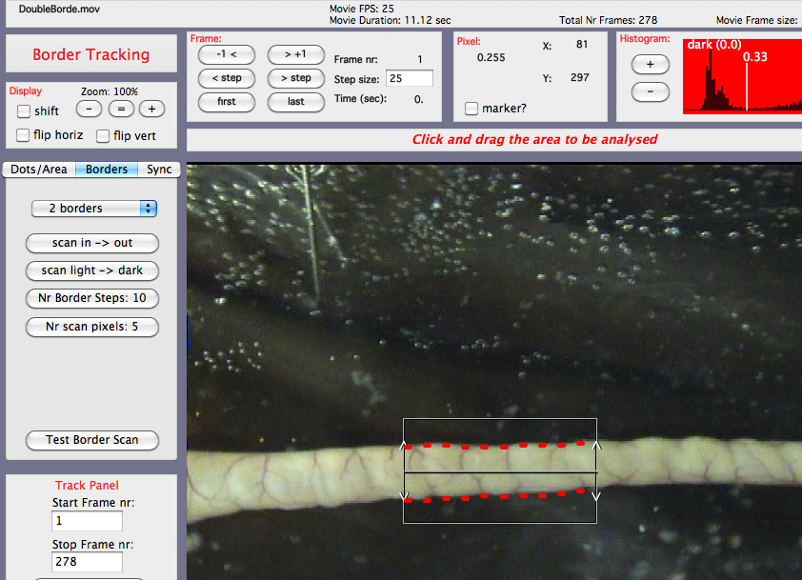
In this example, the selected area was drawn in such a way that the two halves each covered one border. The scan direction border has now changed its meaning a little, it is now either “scan in->out” (as in this case), or “scan out -> in”. The other buttons retain their previous functions.
One of the disadvantages in this approach is that the horizontal split cannot be altered. A second disadvantage is that sometimes, the preparations are curved and do not fit in a rectangular selection. All this has led to the recent addition of the “curved borders” tracking possibility.

Border Mode: Curved Borders:

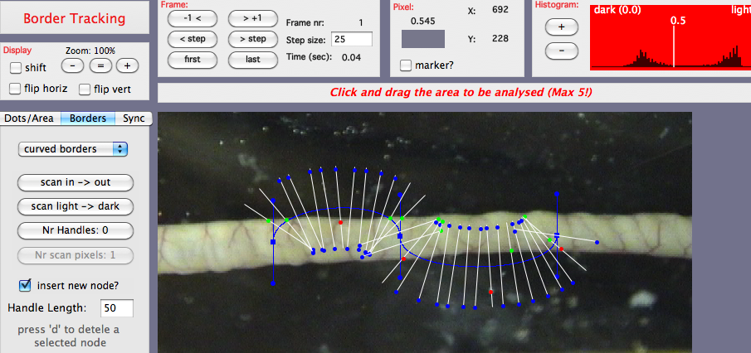

In this Border Mode, instead of dragging a selected area, one clicks on the segment to insert a “node”. Clicking a bit further to the right (as in this example), inserts a second node, a Bezier line between the two nodes and sets of scan lines perpendicular to the Bezier line. In this example, a third node was also inserted. The maximum number of nodes is set at 20.
The location and orientation of the node can be maneuvered by moving the cursor close to the node (blue square) or to the tip of one of the node handles (blue circles). The square or the circle will turn red when the cursor is close enough indicating it can be selected. Clicking and dragging will then move the location or the orientation of the Bezier curve. This was done for the three nodes and handles as shown in the figure below.
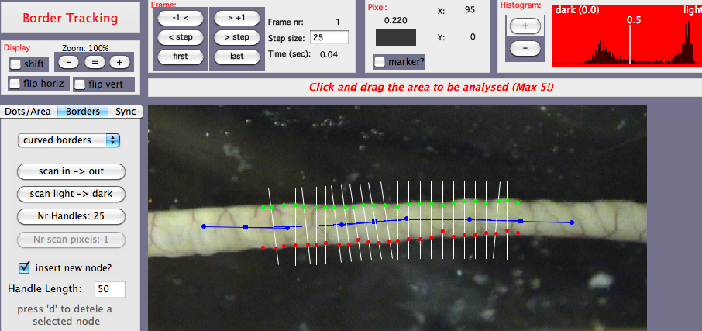
The other buttons have the same meaning as in the previous border. Note while you are doing all this that, in this mode, the scanning is already being performed. The white lines are the scan paths and the red/green dots indicate the border of the segment (if the threshold value in the histogram is set properly). At the moment, whether the border dots are red or green does not have a particular significance and was used for debugging purposes.

TIPS: If you don’t immediately see an effect, move the cursor into the movie area.
To avoid accidentally inserting a new node, you can uncheck the “Insert new node?” checkbox. The edit field in “Handle length” can set the length of the handles. If you want to remove a node, move the cursor to the central square of that node and press “d” on the keyboard.
SORRY: The number of handles (called “border steps” in the other border modes) is an approximation and could turn out to be 1-2 higher or lower than what you wanted.

Dot/Area Mode:
In this tracking mode, there are two subtypes: 1) Dot and 2) Areas.

Dot Mode:
This is actually the oldest mode (1). When this mode is chosen and the cursor moved around the screen, a black rectangle follows the cursor. In the example below, several soot markers had been placed on the serosal surface of the segment. The idea is to click a square onto the marker to be tracked. A red cross and a sequential number indicate a selection. In this example, six soot markers were selected. The size of the square determines the area around the soot marker that will be scanned during the tracking. This area must not be too large or it may interfere with neighboring markers but also not too small or you might easily “loose” the marker during tracking. This is all a matter of trial and error. The size of the area can be set in the “Search size” button. The area size is the same for all dots.
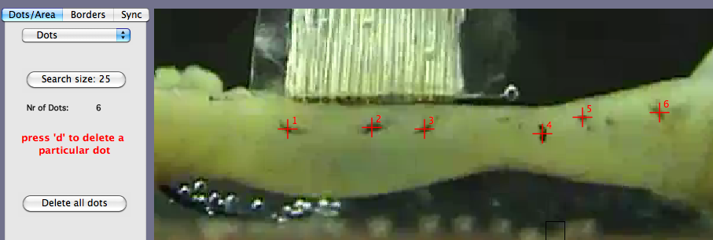
If a marker is not correct, you can move the cursor to that marker and press “d”. You can also dele all dots and start your selection again. The maximum number of dots is 50. There is no test function for this selection.
Actually, if you look closely at what is happening when you click in the neighborhood of a soot marker, you will see that the automatic detection of the darkest point in the square is already performed as the cross very often is drawn at a slightly different position from the tip of the cursor.

Area Mode:
The area mode is a logical extension of the dot mode but is more time consuming in the analysis. In this mode, instead of using an artificial marker, such as soot, which serves as an anchor for the tracking, local available inhomogeneities such as branching blood vessels, fat globules or any other existing surface spots can be used for tracking. In this mode, a two-dimensional correlation analysis is performed of all the pixels in the selected area and compared to that in the next frame. Obviously, this takes much more time that just detecting the darkest spot in an area (as is done in the Dot mode) but is sometimes more effective. However, because of memory constraints, the maximum number of areas that can be simultaneously analyzed is set to 5.
Obviously, this mode can also be used with artificial marker such as in this example:
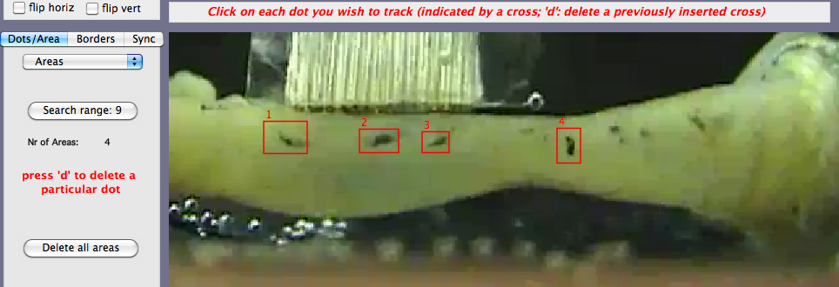
One advantage of the Area mode is that the shape and size of the area to be analyzed is variable but try to keep this as small as possible. Large areas need many more calculations. The settings are similar to that in the Dot mode with the exception of the “Search range” which determines how far the search has to take place (the shorter the faster). I hope soon to publish a paper that describes this method much better then what I could do here.

Sync Mode:
This is the third tab and the third mode of the tracking system. This mode makes it possible to track the lighting behavior of a LED. This is sometimes necessary in my lab when I want to correlate displacements while recording simultaneously electrical activities. I use a stimulator that every second generates 100 msec long impulses (with a second impulse every 10 seconds). Another stimulator output is connected to the electrical recording system.
In this figure, the LED was submerged in the organ bath and positioned next to the electrode array. In the LED mode, it is possible to draw an area around the area of interest. Upon tracking, the light intensity of this area is measured and saved.
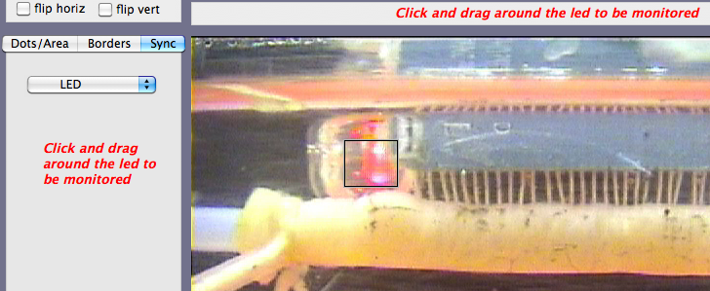

(End of the Tracking Mode panel …)

Track Panel:
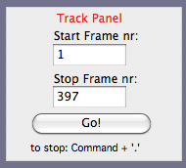 | 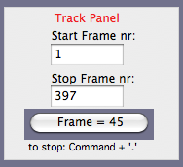

When all is set and ready, then the track panel is the place to go. Pressing “Go!” will start the tracking process. The tracking will start at the value shown in “Start Frame nr” and obviously stop at “Stop Frame nr”. The default values are the first and the last frame number of the selected video file but you may wish to change these if necessary.
Once tracking has started, the actual frame number is displayed in the “Go!” button, and in the Frame panel while the Message panel has changed to a progress bar.
If you want to interrupt the tracking, press “Command + .” (Apple).

IMPORTANT: Be sure to disable any Screen Saver routines during the actual tracking as this may interfere with the tracking of the pixels (dots, borders etc) on the screen.
Re-play Panel:
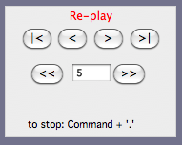 | The Re-play panel is disabled before and during tracking but enabled when tracking is finished or when older traced data are loaded in the program. It provides for a simple way to replay the tracked data forward and backward and at different speeds as indicated by the usual set of buttons on this panel. A more elaborate version of this panel has now been developed in Window#4: PlayBack Window.

LIMITATION:
It is only possible to track one thing at a time. For example, if I would want to track both a border and a LED, I would have to track twice; first in Border mode and then in Sync mode. The same applies to Dot mapping.

This concludes a description of all the panels in window #1; the Tracking Window.

Track Window Menu:
Like all the other windows, the Tracking Window has several options in “menu > Tracking Window”:
- Horiz Flip Type: submenu: a) full screen, b) top part and c) bottom part
- Height to be flipped: (default 50%)
These two menu options were developed for a group that had to split their screen in the horizontal direction. The first option gives you the choice whether you want to flip the top part or the bottom part of the screen. The second option let’s you choose the height of the split (default 50%). In the example below, the lower 75% of the screen was flipped horizontally.
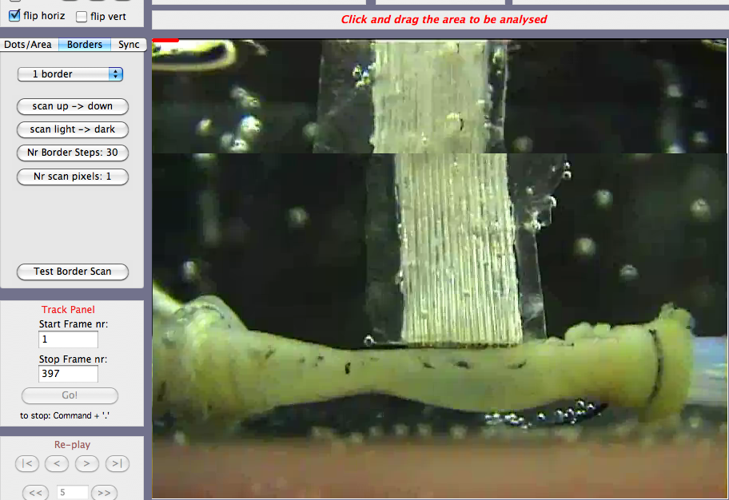 | Example of a split horizontal flip of the lower 75% of the screen. Note that this split only occurs when the “flip horiz” check in the Zoom panel (left) is also checked on.

- Plot Border Arrows: you can remove the two crude arrows that indicate the direction of scanning in the selected area (border mode).
- Dot color (submenu): makes it possible to choose another color for the tracking dots which can be useful depending on the color and the contrast of the video (Dot mode).
- Dot thickness (2): size of the tracking dots (Dot mode)
- Border (dot) color (submenu): similar to the dot colors (Border mode)
- Border (dot) thickness (5): thickness of the border dots (Border mode). Although the scanning is done at the 1 pixel level (or whatever the value is as determined by the “Nr scan pixels”), this is often too small to be visible. Therefore, the size of the dots along the border are made bigger but can be changed with this option.

Examples of different border dot sizes:
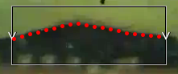 |  | 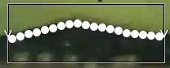
Border dot size = 5 (default) | Border dot size = 2 | Border dot size = 10 and color = white.

Save Tracked Data (text format):

As indicated in the Introduction, tracked data are now saved as text files. Below is a small section of the MouseDistended.dot file. This file consists of several parts:
First, a header, containing information such as name of corresponding files, video size, frame rates, nr of frames, nr of dots etc.
DotFileFormat | 1
MovieFilename | MouseDistented.mov
DotFilename | MouseDistented.dot
TotalNrFrames | 397
FPS | 25
FrameSizeX | 721
FrameSizeY | 577
OrientationDir | 0
SearchSizeDot | 20
NumberOfDots | 6
NrTrackedFrames | 397
StartTrackNr | 1
StopTrackNr | 397
CalibMillimeters | 5
CalibPixels | 50
OrgXCalib | 20
OrgYCalib | 20
Zoom | 1
FrameOrgX | 0
FrameOrgY | 0
CalibHorizontal | TRUE
SyncData | FALSE
empty
empty
…………
empty
empty

And this is a sample of the tracked Data:
FrameNr |  | DotX 1 | DotY 1 | DotX 2 | DotY 2 | DotX 3 | DotY 3 | DotX 4
1 | 0 | 259 | 409 | 330 | 408 | 375 | 409 | 476
2 | 0 | 260 | 410 | 330 | 408 | 376 | 409 | 475
3 | 0 | 259 | 409 | 331 | 408 | 374 | 409 | 471
4 | 0 | 262 | 411 | 332 | 407 | 374 | 408 | 469
………….
395 | 0 | 257 | 403 | 304 | 382 | 368 | 403 | 466
396 | 0 | 258 | 403 | 305 | 382 | 367 | 402 | 463
397 | 0 | 259 | 402 | 305 | 383 | 364 | 403 | 461

And this is an example of markings that were inserted in the Dot Window (see later):
Dot Marks
16
del? | mrkType | trace nr | frame | ampl px
1 | 1 | 1 | 64 | 7 | 0 | 0 | 0 | 0 | 0
1 | 1 | 1 | 96 | 5 | 0 | 0 | 0 | 0 | 0
1 | 1 | 1 | 129 | 7 | 0 | 0 | 0 | 0 | 0
1 | 1 | 1 | 161 | 9 | 0 | 0 | 0 | 0 | 0
1 | 1 | 1 | 194 | 9 | 0 | 0 | 0 | 0 | 0
1 | 2 | 2 | 92 | 26 | 0 | 0 | 0 | 0 | 0
………….
1 | 3 | 2 | 37 | 0 | 0 | 0 | 0 | 0 | 0
1 | 3 | 1 | 47 | -11 | 0 | 0 | 0 | 0 | 0

Below the header, and after a series of empty lines for future use, the tracked data is displayed. Each row displays the data from one frame. As indicated in the first row, the first column shows the frame nr, the second column is used for the sync data (if available) and the next pairs of columns plots the X and Y values of the tracked dots. The units are in pixels and correspond to the coordinate of the video image (origin is 0,0 in the upper left corner).

After all the tracked data have been displayed, this is followed, if available, by the marks that I have inserted in the Dot window (see later). The trace to which the mark refers is plotted in column 3, the frame (i.e. the time) is plotted in col 4 and the amplitude of that mark in col 5. The type of mark (1 = normal, max = 2 and min = 3) is plotted in col 2.

The .are and the .bor. files are very similar to the .dot file with minor variations depending on their characteristics. If two borders have been tracked, then there will be two Y values for each X value in the tracked border columns.

FrameNr |  | X 1 | Yh 1 | Yl 1 | X 2 | Yh 2 | Yl 2 | Yh … | Yl …
1 | 0 | 187 | 297 | 358 | 197 | 297 | 356 | … | …
2 | 0 | 187 | 297 | 358 | 197 | 297 | 356 | … | …
3 | 0 | 187 | 297 | 358 | 197 | 297 | 356 | … | …
4 | 0 | 187 | 297 | 358 | 197 | 297 | 356 | … | …
5 | 0 | 187 | 297 | 358 | 197 | 297 | 356 | … | …

The above is an example of a .bor file in which two borders had been scanned. The values of the high and the lower border are indicated by “Yh x” and “Yl x”. Because the H and L values are always on top of each other, there is only one X value.

The data for an area file consists, after the usual header, of the sizes of each individual area, followed by the tracked X and Y coordinate of those areas:
Area nr: | Area width: | Area height:
Area 1 | 38 | 23
Area 2 | 36 | 20
Area 3 | 25 | 21
Area 4 | 29 | 22
FrameNr |  | AreaX 1 | AreaY 1 | AreaX 2 | AreaY 2 | AreaX 3 | AreaY 3
1 | 0 | 241 | 398 | 308 | 400 | 364 | 399
2 | 0 | 241 | 398 | 309 | 400 | 363 | 399
3 | 0 | 242 | 398 | 310 | 399 | 362 | 398

The data for a curved (double) border:
FrameNr |  | Xh 1 | Yh 1 | Xl 1 | Yl1 | Xh 2 | Yh 2 | Xl 2 | Yl2
1 | 0 | 226 | 351 | 226 | 297 | 264 | 348 | 264 | 295
2 | 0 | 226 | 351 | 226 | 297 | 264 | 348 | 264 | 295
3 | 0 | 226 | 351 | 226 | 297 | 264 | 348 | 264 | 295
4 | 0 | 226 | 351 | 226 | 297 | 264 | 348 | 264 | 295
5 | 0 | 226 | 351 | 226 | 297 | 264 | 348 | 264 | 295

Window #2: DOT Window.

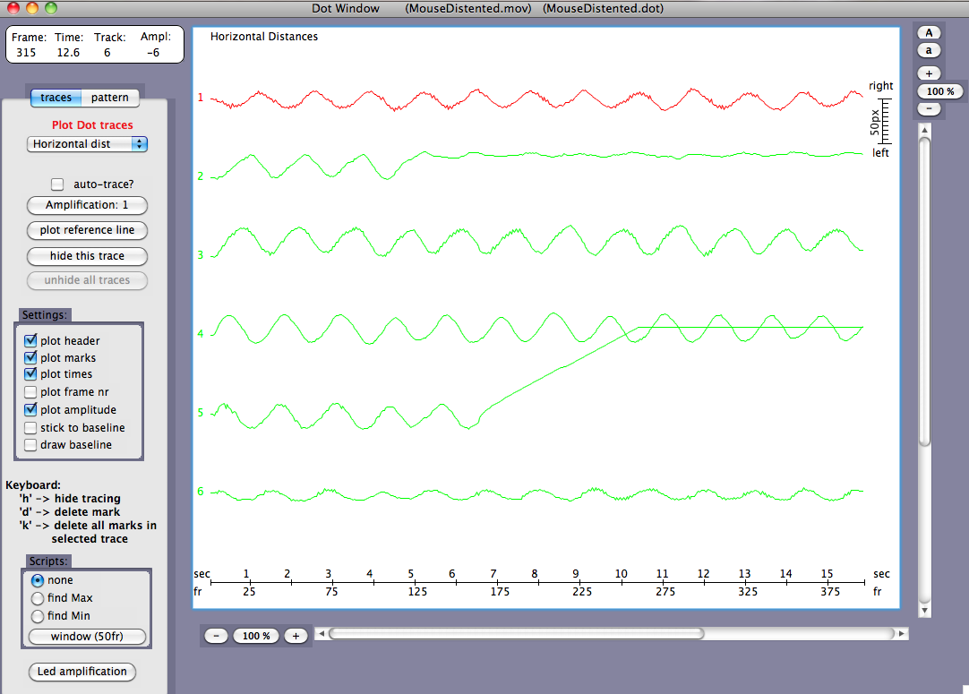

Using the MouseDistended.mov and MouseDistended.dot files, window#2 will display the above graph. (In fact, you don’t actually have to load a movie; the dot files has all the information necessary to display the graphs).
Since 6 dots had been positioned in the movie and tracked, 6 traces are displayed in time in Window#2. At the top in the graph, there is a brief text describing the type of display (more about that later). At the right in the graph, there is a scale for the amplitude of the deflections. If the tracking had been calibrated, the scale is expressed in mm, otherwise in pixels. At the bottom of the graph the time scale is displayed, both in seconds and in frame numbers.
Around the graph, several buttons, scroll bars and panels make a primitive attempt at displaying the data. The scrollbars are activated if the X- or Y-zoom of the graph is larger than 100%. The “+” and “-“ button will zoom the display in or out , in the X- or Y-direction respectively. The zoom factors are displayed in the buttons between the “+” and “-“. In addition, pressing on these buttons will allow you to enter your own choice directly. Finally, in the vertical scale, there are two additional buttons “A” and “a” with which you can increase or decrease the amplitude of the tracings without altering their position on the screen.

IMPORTANT: Since often traces overlap, I have developed a system of “selecting” a trace. The selected trace is shown in red (default is the first trace as shown in the figure). Selection of another trace can be done by pressing repeatedly the “up” and “down” keyboard arrows. You can only select one trace at a time. The values displayed on the dashboard (below) reflect the data from the selected trace (but see also “auto-trace” below).

The following buttons and indicators are available to the left of the graph.

The Dashboard:
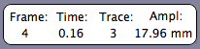  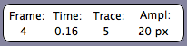 | When moving the cursor around the graph, the frame nr and time will be displayed together with the selected trace number and the amplitude of that signal at that time. The amplitude is given in mm, if calibrated, or in pixels if not.

The Panel:
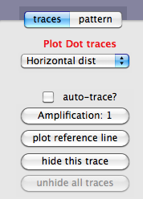 | This tab panel makes it possible to choose between a display of traces (default) or of the pattern of the dot displacements.  The pull-down menu below this has several menu’s (see later).

Check “auto-trace?”: Instead of selecting, with the keyboard arrows, a particular trace, you can also hover with your mouse around the trace you want to select, if this option is checked.

Button “Amplification:” You can change the amplification of the signals (similar to the buttons ‘A’ and ‘a’ at the right vertical scroll bar).

Button “plot reference line” will ask for a specific time and then draw a vertical line through all traces. This is sometimes helpful to discover subtle differences in phase between traces. At the moment, it is only possible to plot one single reference line.

Button “hide this trace”: sometimes, as in this case dot#2 and #5, the dots have lost their marker during the tracking. If necessary, you can hide these traces. “Unhide all traces” will un-hide them if necessary.

Pull-down menu (default Horizontal displacements):

1. Horizontal: plots the horizontal displacements of the dots (in this example in the longitudinal direction of the intestine) starting at the first value in the first frame
2. Vertical : same as horizontal but in the vertical direction, in this example in the circular direction.
3. Absolute : The absolute distance from the starting point in the first frame, irrespective of the direction of the displacements.
4. Horizontal dist: Distance between two dots measured in the horizontal direction.
5. Vertical dist: Distance between two dots measured in the vertical direction.
6. Absolute dist: Absolute distance between two dots.
7. Chain: Distance along a series of dots relative to the first value.

IMPORTANT: In the case of options 4-7, the program needs to know which dots should be used for these measurements. Therefore, a short text file should be loaded before plotting these display types (examples are shown later)

Settings:
As a crude way in analyzing these tracings, I have developed the possibility of marking events of interest in the selected tracings.
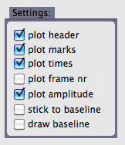 | This set of checks offers the possibility of tailoring these marks. For example, you can plot the times and/or the frame numbers adjacent to each mark, plot the amplitudes (in pixels or in mm if calibrated) or have the inserted marks stick to the baseline. The last check offers you the possibility of drawing the baseline.

Keyboard:
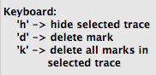 | To save time, I often use keyboard short cuts. These three short cuts speak, I think, for themselves.

Scripts:
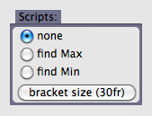 | These scripts are short routines with which one can detect and mark the maximum or the minimum value in a particular segment of the trace. The length of the segment/ bracket (default 30 frames wide) can be altered with this button.

In the example below, the “find Max” script was chosen. Moving the cursor around the traces will plot a bracket. The length of that bracket is determined by the button below the scripts (“bracket size”). When you want to detect automatically the top (or the bottom of a curve), hover with the mouse around such an area and press the button. The program will automatically determine the maximum (or the minimum) amplitude in the selected trace within the range of the bracket. The type of mark will be indicated by a small circle at the top (or at the bottom of the mark), to differentiate these two from a manual mark.

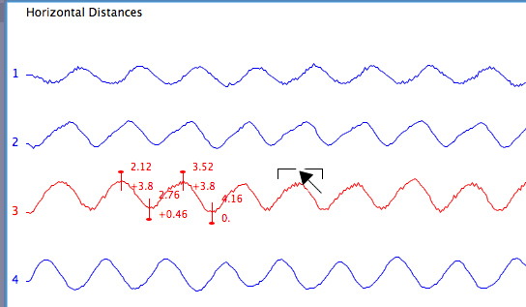

Second example:
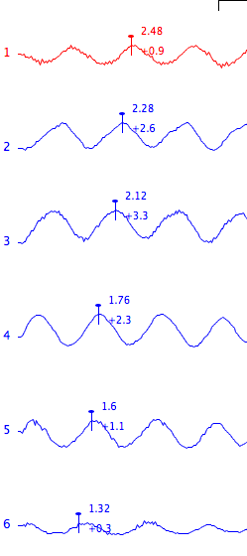 | In this example , I have set the auto-trace on, set the script to “find Max”, and quickly marked this propagating contraction.

In the case of a LED trace, the amplitude of that signal can be altered independent of the other tracings.

Distances between dots:

It is possible to graph the distance between pairs of dots. For this a small text file needs to be imported so that the program knows which dot pairs it has to calculate the distance between.

5  1 (tab) 2  2 (tab) 3  3 (tab) 4  4 (tab) 5  5 (tab) 6 | An example of such a text file is included in the Supporting Files folder (MouseDistendedDotList.txt). It essentially consists of a few lines. The first number indicates the number of traces you want to plot. The next five lines gives the number of each dot pairs (tab-delimited) you want to plot. This is easily done in for example in Excel (don’t forget to export as tab-delimited text file).

Once imported, the “Horizontal distances” will plot the left figure while the “Vertical distances” will plot the right figure. As you can see, contraction mostly occurred in the longitudinal direction.

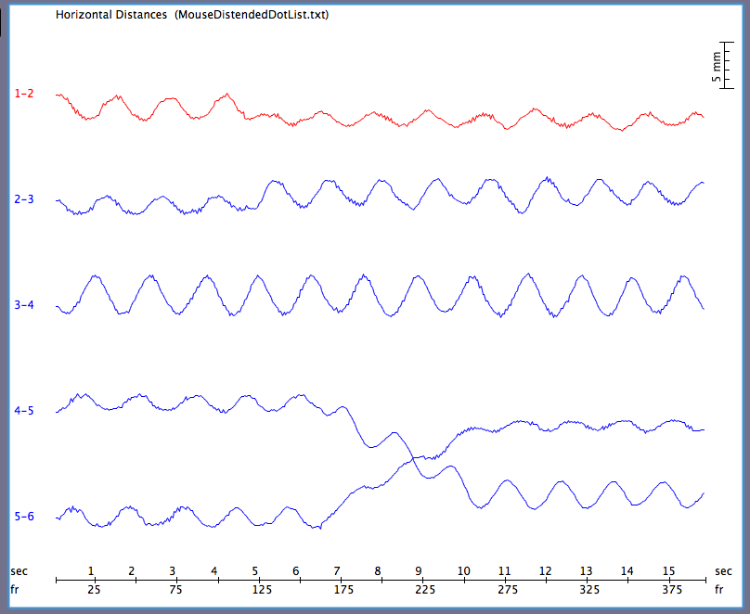 | 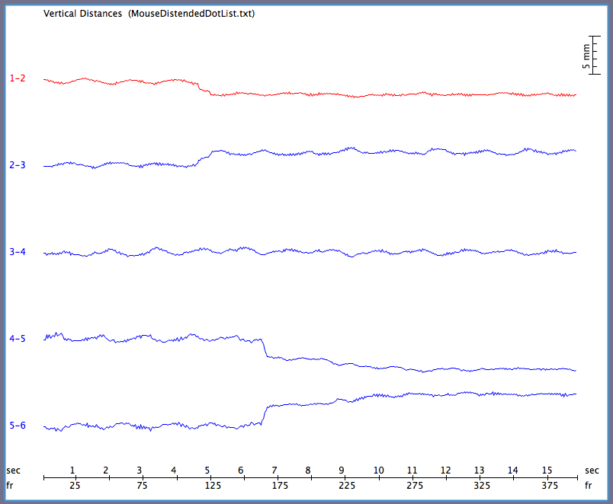

Chain List:
This is a new addition to the program, as I wanted to monitor a lengthy stretch of tissue behavior. So, instead of calculating the distances between each dot pair, I now calculate and plot the distances between successive dots in a “chain”. The example here shows a simple chain of 9 dots. Again, a text file needs to be imported (MouseDistendedChainList.txt) which is simply a list of successive dot numbers preceded by the number of dots. I used it for example to monitor the contractions of an isolated guinea-pig pregnant uterus.

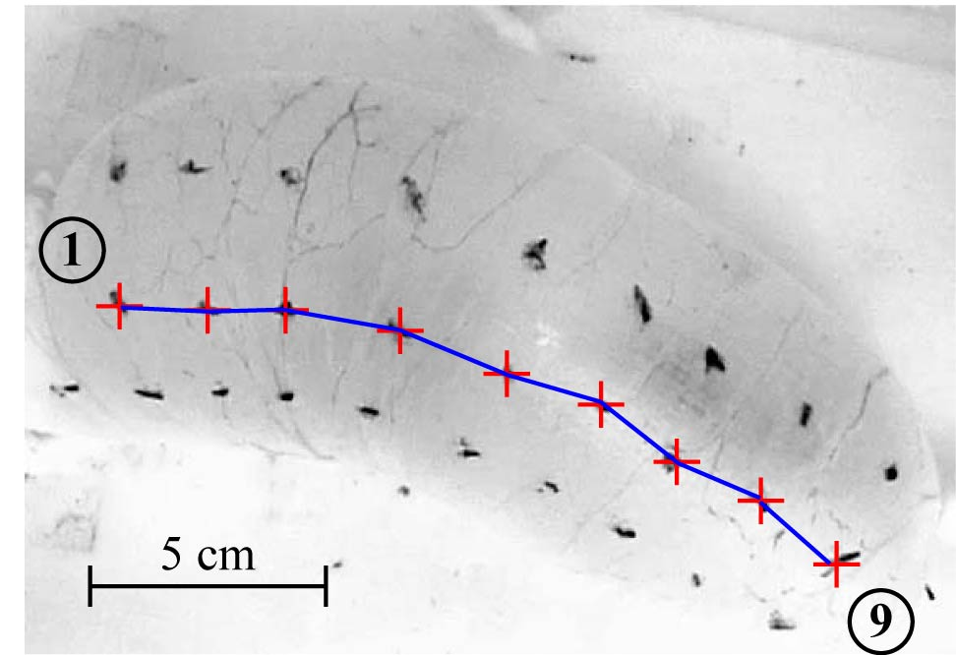 | Left is an example of a “chain” of nine markers/dots stringed along the superior surface of an isolated guinea-pig pregnant uterus in vitro. The idea is to monitor this length during spontaneous contractions.
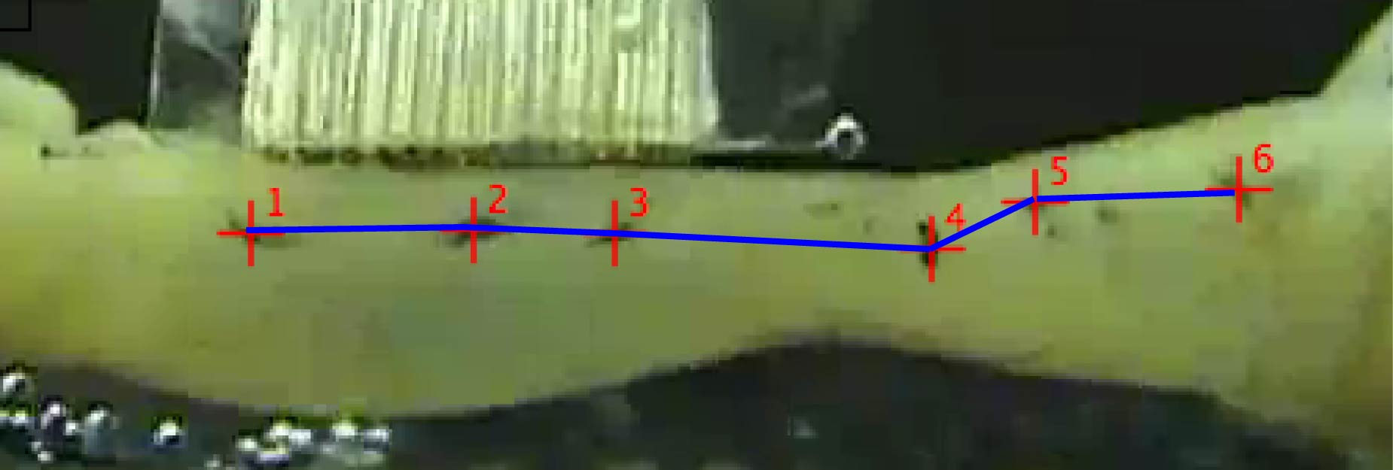 | This is a simple example of a 6-dot chain of our demo file (left) and the chain text file (right). The first value gives the number of dots in the chain, the others values are the dot numbers. | 5  1  2  3  4  5  6

The Pattern Panel:
This panel is not very well developed but could occasionally be useful. It really only shows the pattern or the trajectories of the dots during the movie. The first frame of the movie can be plotted “behind” the trajectories. You can “shrink” the pattern by changing the start and/or the stop frame number.

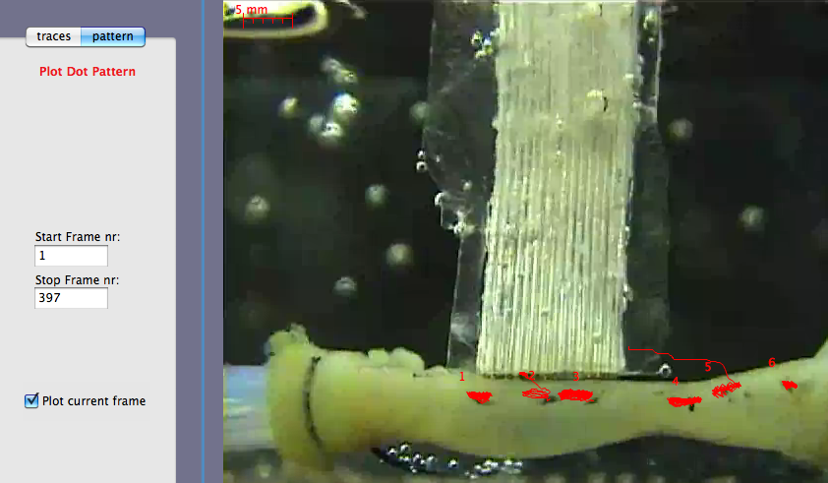
As with other graphs and pictures, you can save this as a jpeg (menu>file>Save as Jpeg).

Dot Window Menu Bar:
There are several options available in the Dot Window Menu bar:
- Begin frame nr: provides an input to change the beginning of the traces.
- Window frame nr: with this you can determine the width of the traces. If the value (together with the begin frame nr) is higher than the total nr of frames analyzed then this value is shortened.
- Plot dots: If you want to see the individual frames in the tracings, you can see those by plotting (small) dots at each frame point.
- Dot size: size of the frame dots if they are plotted (default 3 pixels)
- Kill all dot marks: removes all the marks in all traces (this is different from keyboard-K which only deletes all marks in the selected trace).
- Dot Header Text: this gives you the opportunity to write another piece of text on top of the graph then the current one, for example, when preparing a slide and before exporting a jpeg or a print of the display.
Window #3: BORDER Window.

The function of the Border window is similar to that for the DOT window; to plot the displacements in time. Therefore, many of the facilities available in BORDER window are the same in the DOT window and do not need further explanation.
Panel Traces:
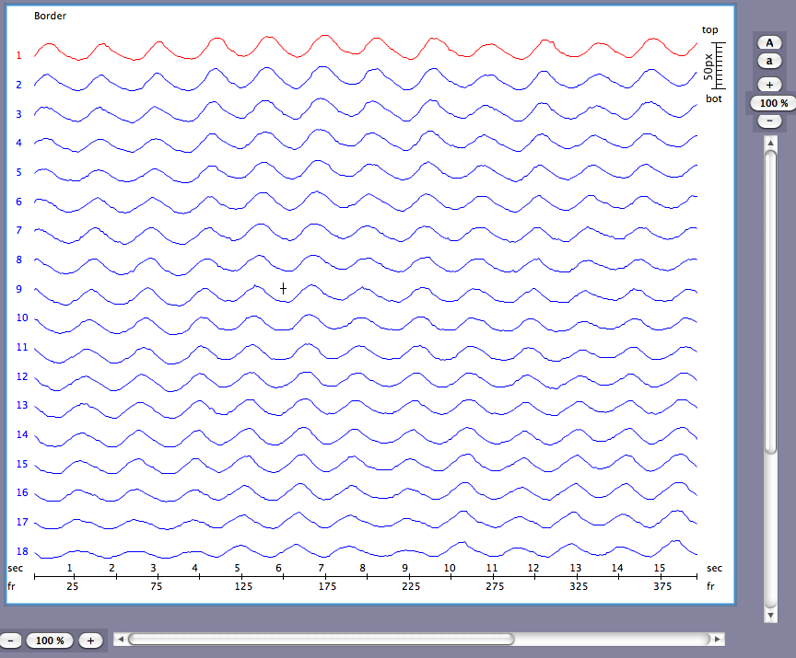
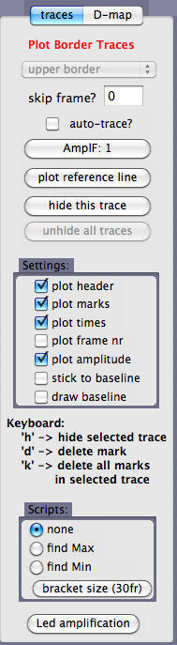 | In the Trace Panel, again most functions are the same, such as:  - auto-trace  - Amplification  - Reference time  - Hide and unhide traces  - settings panel  - keyboard strokes  - scripts  - and the LED amplification

The major difference with the DOT window is the pull-down menu in the mode panel.
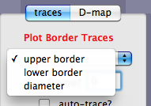 | In the pull-down menu, there are three options:  - upper border  - lower border  - the distance between these two (i.e. the diameter).  NOTE: if only one border has been selected and analyzed, then this option will be dimmed.

Option D-Map:

In this option, the displacements of the border(s) are plotted in a D-map, also called a spatio-temporal maps map, first introduced by Benard and Bouchoucha in 1997 (4) and made popular by Grant Hennig and others in many of their publications. Since this is a fast and easy way to display data, I have included this option in MotilityMap. An example, using the tracing shown at the beginning of this chapter, is shown here:
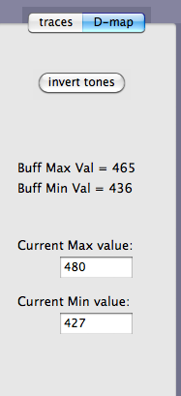 | 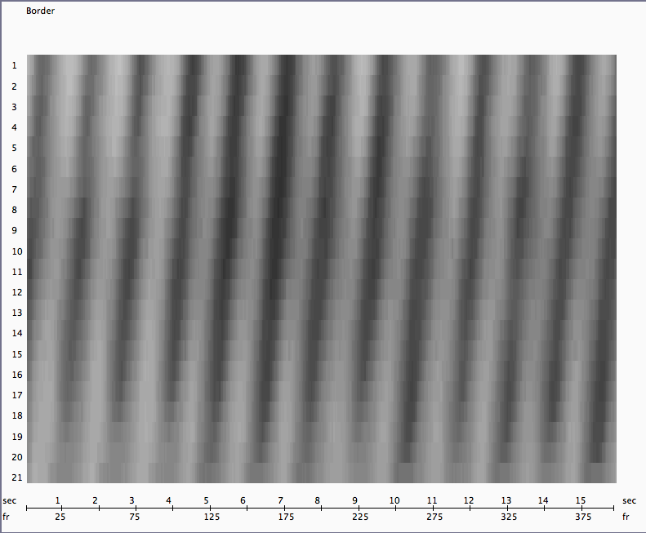

At the moment, there is an option to invert the scale and to print this map or save it as a digital picture (jpeg, etc). Furthermore, as you know, the grey tones are plotted in relation to the diameter or the displacement of the border with respect to a range. For the sake of simplicity, this range is determined by the Y-values of the original selected area with which the border scanning had been performed (in pixels). These values are plotted in the edit fields: “Current Max value:” and “Current Min value:”. Additionally, for your information, the routine also calculates the maximum and minimum values detected during the scanning (displayed as Buff Max Val and Buff Min Val). The edit fields allows you to impose another range to the Dmap calculations if you so wish.
Let me know if you want to incorporate other options in this display mode.

Border Window Menu Bar:
The same options are available in the Border Menu bar as they were in the Dot window menu bar and have the same functions:
- Begin frame nr: provides an input to determine/change the beginning of the traces.
- Window frame nr: with this you can determine the width of the traces. If the value (together with the begin frame nr) is higher than the total nr of frames analyzed then this value is shortened.
- plot dots: If you want to see the individual frames in the tracings, you can see those by plotting (small) dots at each frame point.
- dot size: size of the dots if they are plotted (default 3 pixels)
- Kill all border marks: removes all the marks in all traces (this is different from keyboard-K with only deletes all marks in the selected trace).
- Border Text: this gives you the opportunity to write another piece of text on top of the graph then the current one, for example, when preparing a slide and before exporting a jpeg or a print of the display.

A NEW option in the Border Menu Bar is the ”skip frames” option:
Skip-frame option:
Because there are usually many more border traces plotted then dot traces (in DOT window), the program may sometimes react a bit sluggish since it has to retrace quite often all this data. To increase the reaction speed, it is possible to display less data (by skipping frames). This obviously will also filter your traces and it is up to you to compromise on this issue. It also obviously depends on the quality and the speed of your computer.
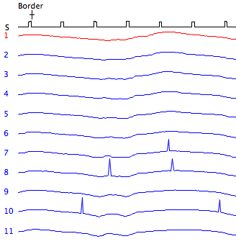 | 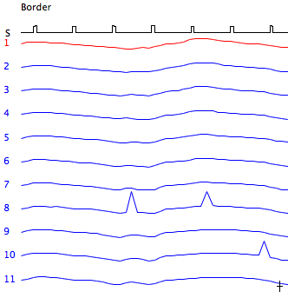
Example of skipping frames: left – no skipping, right – 5 frames skipped. This reduced the numbers of missed borders and has a negligible effect on the contraction pattern (in this case!).

Window #4: PLAY BACK Window.

This is a new window that allows me to plot and play back data from files produced and saved in previous windows; video files, DOT files, BOR files and ARE files. In the following overview, the usual example files MouseDistended.mov, .dot and .bor files were imported and displayed in window#4:

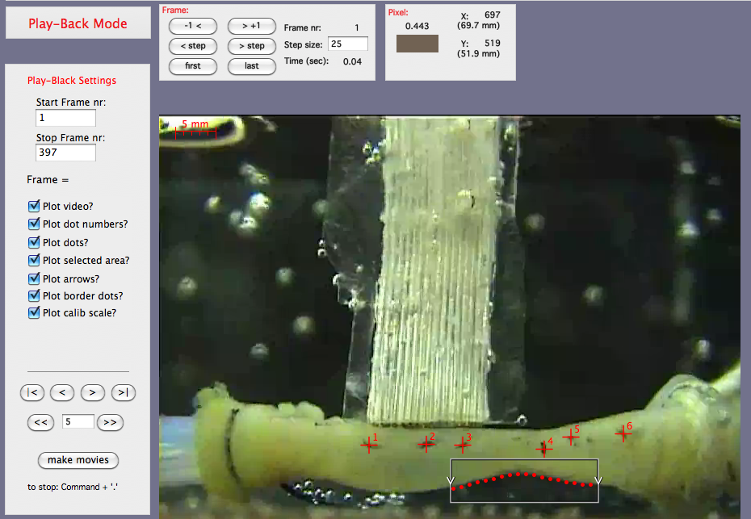
The window looks a lot like the Tracking window but several panels have been left out and there is a new panel “Play-Back Settings”.
Also, in the figure, note the simultaneous presence of both the dots (with their numbers) and the detected lower border segment (with the selected area and the arrows). In the Settings panel, every one of these options can be checked and displayed on or off. You can also uncheck the video and produce an animation: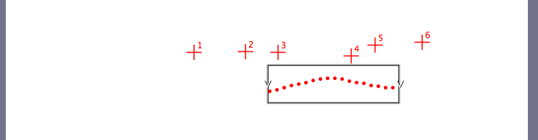

The buttons in the lower part of the Settings panel allows you to re-play forward or backward, frame by frame or in steps, similar to what was already possible in the Tracking Window. And there is a new button “make movies”.

Make Movies:
If this is pressed, then you are asked to give a name to this “New Movie” and you can select the type of movie. I have no idea of all these possibilities but I always choose “Video” which, on my laptop, produces a QuickTime movie.

Caution: It is not possible to plot “dots” and “areas” at the same time, nor did I see a reason why this would be necessary, but if someone needs this option, let me know.

Technical Details and Tips

As stated in the Introduction, MotilityMap 3.0 only works on the Macintosh platform. It has been tested on a MacBook Pro (MacOS 10.6, 2.66 GHz Intel Core 2 Duo, 1440x900), on a MacBook MacOS 10.4.11, 1280x800, 512 MB Intel Core Duo) and a MacMini (similar configuration). The resolution must be high enough and the RAM large enough for Motility Map to work properly. Occasionally, the program may crash. This is often due to the fact that too many other applications are running at the same time. Closing the applications and restarting the computer may solve this problem.

For the video recording I have used an off the shelf simple camcorder such as Handycam (DCR-HC 32 E PAL) from Sony. I like this type because the video is stored on a small DV tape, which allows for uninterrupted recording time of 1 hour. After the experiment, the video is simply connected to the computer and the chosen segment loaded. It depends on your machine and operating systems how this works for you.

Depending on the tissue, I record either from a stand vertically down the tissue bath or horizontally through the transparent Perspex wall of the organ bath (as in the MouseDistended movie). For border mapping, it is best if the background has a high contrast with the tissue. For this, I place a black surface or object at the other side of the organ bath (back of a CD).

For the dots, I place soot markers with a fine needle. Soot differs tremendously in composition and this needs some exploration. For example, I find the soot of many candles too fine and we now use castor oil, which we burn with a cotton wick. We allow the flame to burn on the outside surface of a Pyrex flask or beaker which will deposit a nice “fat” layer of soot. With a fine needle I scrape some soot and place that careful against the tissue. Touching is enough; there is no need in “injecting” or pricking the tissue!

SUPPORTING FILES:

- MouseDistended.mov: This is the movie that we used extensively in this manual. It is available in zipped and stuffed format as some systems will not allow you to download QT directly.
- MouseDistended.dot: the analyzed 6 dots of this movie.
- MouseDistended.bor: the lower border analysis of this movie.
- MouseDistended.are: an area analysis of this movie.
- MouseDistendedDotList.txt: example of a text file of dot pairs to be imported for the analysis of distances between markers.
- MouseDistendedDotChain.txt: example of a chain text file

All these files are available at www.smoothmap.org (> Softwares).

REFERENCES.

- Lammers WJEP, Dhanasekaran S, Slack JR, Stephen B. Two dimensional high resolution motility mapping. Methodology and initial results. Neurogastroenterology & Motility 13, 309-323, 2001

- Lammers WJEP. Spatial and temporal coupling between slow waves and pendular contractions. Am J Physiol 289:G898-G903, 2005

- Seerden TC, Lammers WJEP, De Winter BY, De Man JG, Pelckmans PA. Spatiotemporal electrical and motility mapping of distension-induced propagating oscillations in the murine small intestine. Am J Physiol 289:G1043-G1051; 2005

- Benard T, Bouchoucha M, Dupres M, Cugnenc PH. In vitro analysis of rat intestinal wall movements at rest and during propagated contraction: a new method. Am J Physiol 273: G776-G784, 1997.

Al Ain, United Arab Emirates
April 11, 2010

